SDMX-HD (Health Domain)

Version 2009.07.WHO.01

July 2009

Contributors
Contributor | Organization / Company
Patrick Whitaker | WHO
Gary Patchen | blue-infinity
Xavier Bocken | blue-infinity

Revision History
Date | Version | Status
2009-02-19 | .01 | Draft
2009-03-30 | .02 | Draft
2009-04-22 | .03 | Final draft, including feedback from Arofan Gregory (Metadata Technology)
2009-04-30 | .03 | Last update to final draft, taking samples into account
Contents
A Introduction 6
B High-Level Overview 7
B.1 Information model 11
B.2 Concepts for Data Structure Definition (DSD) 13
B.3 Concepts for Metadata Structure Definition (MSD) 16
C SDMX-HD 19
C.1 File organization 19
C.2 XSD schema validation 21
C.3 Data and metadata structure overview 23
C.4 Versioning 24
C.5 Data Structure Definitions (DSD) 25
C.5.1 Headers 25
C.5.2 Body 27
C.5.2.1 Code-lists 27
C.5.2.2 Special Code-lists 28
C.5.2.3 Hierarchical Code-lists 29
C.5.2.4 Concept Schemes 32
C.5.2.4.1 Concepts 32
C.5.2.4.2 Key Families 33
C.5.2.4.3 Primary Measures 34
C.5.2.4.4 Dimension 35
C.5.2.4.5 Groups 35
C.5.2.4.6 TimePeriod 35
C.5.2.4.7 Attributes 36
C.6 Data 38
C.6.1 Headers 38
C.6.2 Body 38
C.6.2.1 Dataset 38
C.6.2.2 Groups & Series 38
C.6.2.3 Observations (Obs) 40
D Metadata 40
D.1 Metadata Definitions 41
D.1.1 Headers 41
D.1.2 Body 41
D.1.2.1 Code-lists 41
D.1.2.2 Concepts 41
D.1.2.3 Metadata Structure Definition 43
D.1.2.3.1 IdentifierComponent 44
D.1.2.3.2 ReportStructure 45
D.1.2.3.2.1 Metadata Attribute 45
D.2 Metadata Set data 46
D.2.1 Headers 46
D.2.2 Body 47
D.2.2.1 Metadata Set 47
D.2.2.2 Attribute Value Set 47
D.2.2.2.1 TargetRef 48
D.2.2.2.2 TargetValues 48
D.2.2.2.2.1 ComponentValue 48
D.2.2.2.3 ReportedAttribute 49

Introduction

The adoption of ISO/TS 17369:2005, Statistical Data and Metadata Exchange (SDMX) by the UN for aggregate data will contribute to efforts to promote computer system interoperability and data use. The SDMX-HD standard is the WHO implementation of ISO/TS 17369:2005 which is implemented in the WHO Indicator and Measurement Registry (IMR), a facility for harmonizing, managing, and publishing computer-readable indicator definitions, and other applications in the Health Domain (HD).
The SDMX-HD standard is intended to be part of countries' Health Information System (HIS) and Monitoring and Evaluation (M&E) infrastructure-strengthening strategy, facilitating seamless flow of information from facility to district, national, and international levels in the absence of well-developed Internet access. It also promotes specialized functionality of others systems supporting the standard to be leveraged, making application development more cost-effective. For example, if geographic mapping is desired, the data can be easily imported into those applications supporting the format, eliminating the need to replicate the same functionality in an application.
Data exchange usually occurs through negotiation of file formats between partners with documentation consisting of a file format or a dictionary. The further data is removed from its source the more important metadata, or data about data, becomes to unambiguously describe data. As shown in subsequent sections, the SDMX-HD standard defines attributes of a data items, which reduces the negotiation required to exchange data.
The SDMX-HD standard incorporates M&E and informatics requirements for content, providing a transparent and concise path for computer applications to conform to international standards. In some cases however, applications may need to be revised to support the standard, support for dimensional data being a prominent example. It will be a useful benchmark for countries to evaluate applications being considered for M&E systems.
This document is aimed at a technical audience with the primary objective of explaining how to exchange indicator definitions and data using the SDMX-HD standard. The reader is assumed to have good knowledge of the SDMX Technical Specification. Additional documentation is available online from http://www.sdmx.org. The SDMX User Guide version 2009.1 is a good starting point. A Google Group has also been created to promote the development of a community around the SDMX-HD to promote its use. The site can be found at http://groups.google.com/group/sdmx_hd.

High-Level Overview

ISO/TS 17369:2005, Statistical Data and Metadata Exchange (SDMX) describes statistical metadata through a data structure definition, or DSD, which defines concepts, dimensions, attributes, code-lists and other artifacts necessary to describe the structure of data. In a parallel manner, a metadata structure definition, or MSD, describes metadata associated with data at observation, series, group, and dataset levels.

When these SDMX structures are combined with metadata attributes recommended in international standards and harmonized across programmes, a message that will satisfy a majority of requirements can be developed. The standards referenced in this document include:

- ISO/TS 17369:2005, Statistical Data and Metadata Exchange (SDMX)
- ISO 15836:2003, Information and documentation - The Dublin Core metadata element set
- Data Documentation Initiative (DDI)
- ISO/IEC 11179, Information Technology -- Metadata registries (MDR)
- ISO 3166-1, Codes for representation of names of countries and their subdivisions- Part 1: Country codes
- ISO 3166-2, Codes for the representation of names of countries and their subdivisions – Part 2: Country subdivision code
- ISO 4217, Codes for the representation of currencies and funds

The attributes in the SDMX-HD standard provide an entry point into metadata management, a subset of attributes from these standards having been incorporated into the SDMX-HD model. It is expected that more metadata attributes will be adopted as the business cases for interoperability mature.

Harmonization of indicators and metadata is a concern. As a result, the current emphasis of this standard is accommodating current reporting and M&E requirements in an absence of centrally-managed indicator definitions and metadata. This has required enhancements to the SDMX-HD standard in some cases. Examples of these health domain-specific requirements include:

- Association of indicators with clinical concepts, e.g. International Classification of Disease (ICD) and Detailed Clinical Models (DCMs);
- Inability to preenumerate concepts, code-lists, partners and programmes;
- Programme-specific metadata views and code-lists, e.g.

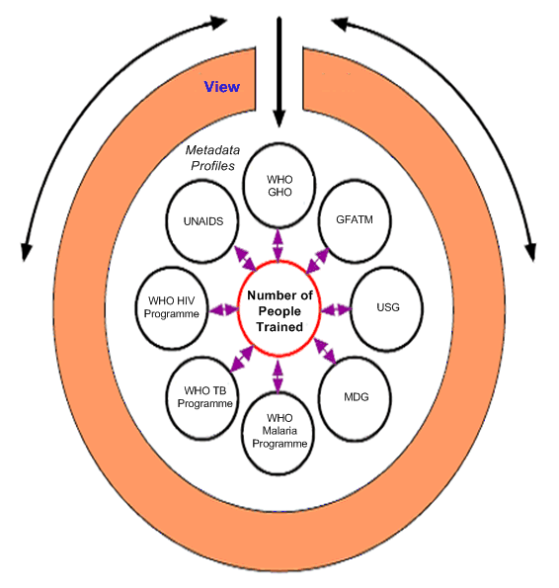
The SDMX-HD standard will initially be implemented in reference applications supported by WHO, development communities, and partners. The initial of applications which form a testbed for facility-to-international reporting include the following:

- WHO Indicator and Metadata Registry (IMR)
- USG COPRS II - Headquarters aggregate M&E system
- USG CRIS PEPFAR - Country aggregate M&E system
- OpenMRS Express:HIV - Antiretroviral (ART) patient monitoring

The remainder of this document presents the technical documentation for the SDMX-HD standard, including SDMX documentation, SDMX-HD specific documentation, data model, data structure definition (DSD), metadata structure definition (MSD), and implementation guidance for programming staff.

At the heart of modeling statistical data and metadata in SDMX is the notion of SDMX Information Model. The data (and related metadata) for a particular statistical domain are structured according to a "Data Structure Definition" (DSD). The DSD describes the structure of a particular statistical data flow through a list of dimensions (for example: country, variable/topic, year), a list of "attributes" (for example, unit of measure) and their associated code-lists. Attributes are metadata about an individual value, a time series or a group of time series.

SDMX also defines a model for additional explanatory metadata, which are often referred to in SDMX as reference metadata. Reference metadata are generally in a textual format, using concepts describing the content, methodology and quality of the data, structured according to a “Metadata Structure Definition” (MSD).

In the health domain, aggregate data is usually obtained and exchanged in the form of indicator values, typically reported as time series classified by various dimensions such as “by geography” (country or sub-national), “by organization”, “by programme”, etc. An indicator itself is defined by its name and various metadata such as its data type, definition, rationale, topic, measurement method, method of estimation, etc. The data structure is further complicated by the notion of disaggregated indicator data (by gender, by age group, by education, etc.) and by the fact that some indicators are calculated by combining results of other indicators, e.g. a percent indicator (prevalence of…) being calculated by numerator (count of…) divided by denominator (population).

An overview of the ideas behind structuring aggregate health domain data and metadata is best given by a graphical example.
The screenshot below is obtained from WHO’s Statistical Information System (WHOSIS), available at http://www.who.int/whosis/en/.

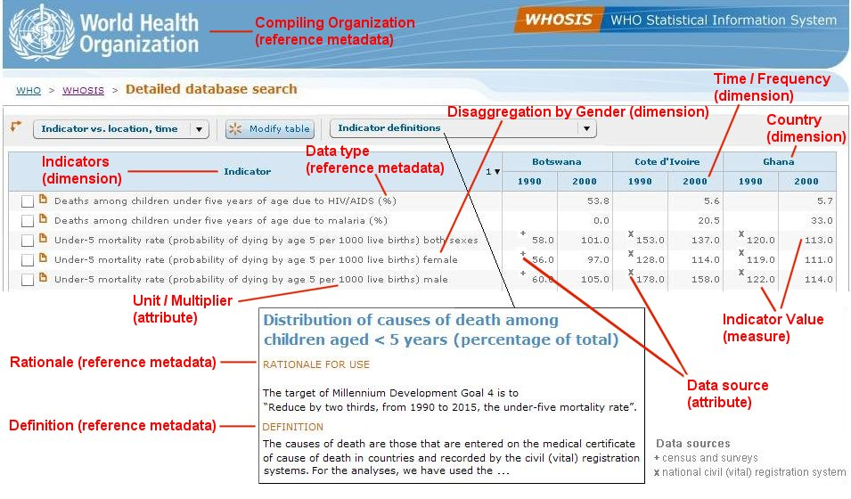
Contrary to other domains where SDMX is in use and all agencies are able to reach an agreement on the full data structure prior to exchanging data, the health domain is more evolving in nature. Indicator definitions are often revised and new indicators are regularly published. Even though harmonization initiatives are more and more common, one should assume that indicator definitions and other dimensions (e.g. disaggregation) are changing and as such, cannot be defined in an agreed code-list. This has important consequences on the SDMX-HD standard, which:
- Allows for the exchange of indicator definitions and metadata without any associated data, for the sake of making publicly available standardized indicator definitions to help harmonize data collection processes;
- Defines a core set of common concepts and code-lists that must be used in the SDMX-HD message to be compatible with the standard, whereas a list of supplemental custom concepts and code-lists is provided by each agency whenever broad agreement on these concepts has not yet been reached;
- Allows for the exchange of indicator data and metadata, structured according to the common data structure definition concepts, according to the relevant indicators and according to supplemental custom concepts as appropriate.

Another important factor to take into consideration is that health domain aggregate data often results in incomplete matrices. Even though an indicator definition may recommend data collection disaggregated by gender (males, females), a particular country may only be able to report the total figure, or data might not be available on a regular basis, thus creating gaps in the time series. Thus, the SDMX-HD standard also provides the ability to:
- Report incomplete data, by making use of special “missing values” to distinguish between an actual indicator value of 0; an indicator value that is reported to be missing (cannot be obtained); or an indicator value that is not reported but may exist (absent from the data set).

Information model
An indicator definition is essentially made of:
- The indicator name;
- Various disaggregations that participate in the identification of the time series (e.g. age group, gender, etc.);
- Various metadata such as its code, data type, definition, rationale, topic, measurement method, method of estimation, frequency, preferred source, etc.

Some of the indicator metadata defines the methodology to follow to collect data (e.g. definition, method of estimation, preferred source) whereas some metadata provides guidance on how the data set should be constructed (e.g. disaggregation, frequency).

Particular attention must be paid to:
- The fact that even though an indicator definition may recommend reporting data disaggregated by gender and age group, such data might not be available and so the reported data set might not use these concepts as dimensions.
- Not misunderstand some concepts used as metadata for an indicator definition that might seem similar to concepts used as dimensions in the data set. For example,
  - frequency defines the recommended frequency of data collection: the concept is used as indicator definition metadata;
  - periodicity is the actual frequency of compilation of the data: the concept is used as a metadata attribute of the time series;

For example, look at this indicator:

Item | Value
Indicator Name | Under-5 mortality rate (probability of dying by age 5)
Data Type | Ratio
Disaggregation | Gender (Male, Female, Both sexes)
Unit | Per live birth
Multiplier | 1000
Date of last metadata update | January 1st 2001

We would break down this data into the following SDMX-HD structures:

SDMX-HD File | Item or Value
DSD | Indicator Name = Under-5 mortality rate (probability of dying by age 5)
DSD | Disaggregation = Male, Female, Both sexes
DSD | Unit = Per live birth
DSD | Multiplier = 1000
MSD + GMS | Data Type = Ratio
MSD + GMS | Date Collected = January 1st 2001

As you can see from the data above some items are string or dates, whereas some items are selected from a list of values. In SDMX these lookup references are called code-lists. For example the Data Type can be %, Count, Money, Ratio, Statistic, Logical, etc. Other examples of code-lists are gender and age group, etc. We can group the SDMX-HD code-lists as follows:

- COMMON – These are code-lists that do not change across agencies
  - E.g. – CL_DISEASE
- CUSTOM – These are code-lists that are specific to the agency that uses them
  - E.g. – CL_AGROUP

Each concept is given a default core representation code-list so concepts that require different code-lists (i.e. CUSTOM) will be given a default code-list which should be used if no code-list is specified for the Concept.

So far, we have looked at the data and metadata structures needed to represent an indicator definition. What is missing from this example is obviously how to represent the data, but also in which context the data was observed. Let’s take the same example and add the other dimensions that participate in the identification of the time series, such as Geographical Place, Time Period and the Organization that provided the data.

Item |  | Value
Indicator Name |  | Under-5 mortality rate (probability of dying by age 5)
Data Type |  | Ratio
Disaggregation |  | Gender = Male
Unit |  | Per live birth
Multiplier |  | 1000
Date of last metadata update |  | January 1st 2001
Indicator Value |  | 60
Geographical Place | Botswana
Time Period | Year 1990
Organization | WHO
Disease | HIV

The tables above maps to the SDMX-HD structures like this (note the presence of a new compact dataset that holds actual data values):

SDMX-HD File | Item or Value
DSD | Indicator Name = Under-5 mortality rate (probability of dying by age 5)
DSD | Disaggregation concept = Gender (Male, Female, Both sexes)
DSD | Unit = live birth
DSD | Multiplier = 1000
MSD + GMS | Data Type = Ratio
MSD + GMS | Update = January 1st 2001
Compact Dataset | Indicator Value = 60
Compact Dataset | Disaggregation choice = Male
DSD | Geographical Place concept
Compact Dataset | Geographical Place = Botswana
DSD | Time Period concept
Compact Dataset | Time Period = Year 1990
DSD | Organization = WHO
DSD | Disease = HIV

As indicator data is primarily recorded over a time scale, the time period dimension is used to represent this time series. The primary measure dimension is used to identify the observed value for an indicator i.e. the actual indicator value.

Concepts for Data Structure Definition (DSD)

The concepts included in the Data Structure Definition are:
- Indicator (name);
- All possible dimensions of disaggregation;
- Metadata as attributes at the observation, series, groups and data set levels;

The Common/Custom column refers to whether the concept is part of the common SDMX-HD v1.0 standard, or whether it is a custom concept. Customs concepts are:
- Either part of WHO or other agencies extensions (found under the CUSTOM subfolder)
- Or placeholders code-lists to be customized (modifiable code-lists are marked IsFinal=false), found under COMMON/SDMX-HD

Concept name | Identifier |  | Type @ Attachment level |  | Common / Custom |  | Code-list / type
Age Group |  | AGROUP |  | Dimension |  | Custom | CL_AGROUP
Biologic Sex |  | SEX |  | Dimension |  | Common | CL_SEX
Cause of Death |  | COD |  | Dimension |  | Custom | CL_COD
Cause of Death Type |  | CODT |  | Dimension |  | Custom | CL_CODT
Disease |  | DISEASE |  | Dimension |  | Common | CL_DISEASE
Education |  | EDUC |  | Dimension |  | Custom | CL_EDUC
Gender |  | GENDER |  | Dimension |  | Common | CL_GENDER
Geographic Location |  | GLOCATION |  | Dimension |  | Custom | CL_GLOCATION
Income |  | INCOME |  | Dimension |  | Common | CL_INCOME
Indicator |  | INDICATOR |  | Dimension |  | Custom | CL_INDICATOR
Logical Question Answer |  | LOGICAL_VALUE |  | Attribute @ Observation |  | Common | CL_LOGICAL
Multiplier |  | MULT |  | Attribute @ Series |  | Common | CL_MULT
Periodicity |  | PERIODICITY |  | Attribute @ Series |  | Common | CL_PERIODICITY
Pregnancy Status |  | PREG |  | Dimension |  | Common | CL_PREG
Programme |  | PROG |  | Dimension |  | Custom | CL_PROGRAM
Racial Group |  | RACE |  | Dimension |  | Common | CL_RACE
Sector |  | SECTOR |  | Dimension |  | Common | CL_SECTOR
Setting of the data |  | SETTING |  | Dimension |  | Custom | CL_SETTING
Special Value |  | SPECIAL_VALUE |  | Attribute @ Observation |  | Common | CL_SPECIAL_VALUE
Statistic Type |  | TSTAT |  | Attribute @ Series |  | Common | CL_STYPE
Target Population |  | TPOP |  | Dimension |  | Common | CL_TPOP
Type of Orphan |  | ORPHAN |  | Dimension |  | Common | CL_ORPHAN
Unit of measure |  | UNIT |  | Attribute @ Series |  | Custom | CL_UNIT
Vulnerability Status |  | VULNSTAT |  | Dimension |  | Common | CL_VULNSTAT

The above list only includes concepts related to indicator definitions. To exchange data, additional concepts are needed to complete the keyfamily dimensions required to identify the time series. As such, they are added to the Data Structure Definition. Note that some code-lists require a supplementary hierarchical code-list to impose a structure (e.g. CL_GEOGRAPHIC_PLACE_NAME).

The recommendation is to include all concepts required for data exchange in the DSD, regardless of whether only indicator definitions are shared or whether indicator data is also exchanged.

Concept name | Identifier |  | Type @ Attachment level | Common / Custom |  |  | Code-list / type
Data Source | DSOURCE | Attribute @ Series |  |  |  | Custom |  | CL_DSOURCE
Data Source Type | DSTYPE | Attribute @ Series |  |  |  | Custom |  | CL_DSTYPE
DataSet Comment | COMMENT_DATASET | Attribute @ DataSet |  |  | Common |  |  |  | string
Date of Collection | DATE_COLLECT | Attribute @ Observation |  |  |  | Common |  | Date
Date of Reporting of data | RDATA | Attribute @ Group |  |  |  | Common |  | date
Geographic Place Name | GEOGRAPHIC_PLACE_NAME | Dimension |  |  |  | Custom |  | CL_GEOGRAPHIC_PLACE_NAME
Indicator Value | OBS_VALUE | Primary Measure |  |  |  | Common |  | decimal
Observation Comment | COMMENT_OBS | Attribute @ Observation |  |  |  | Common |  | string
Operand | OPERAND | Attribute @ Series |  |  |  | Common |  | CL_OPERAND
Organization (Providing) | ORGANIZATION | Dimension |  |  |  | Custom |  | CL_ORGANIZATION
Reporting Period | RPERIOD | Attribute @ Group |  |  | Common |  |  |  | String
Sample Design | SDESIGN | Attribute @ Series |  |  | Common |  |  |  | String
Sample Size | SSIZE | Attribute @ Series |  |  |  | Common |  | String
Time Period | TIME_PERIOD | Time dimension |  |  |  | Custom |  | CL_TIME_PERIOD
Value Type | VALUE_TYPE | Dimension |  |  |  | Common |  | CL_VALUE_TYPE
Year of First Available Data | FDATA | Attribute @ Group |  |  | Common |  |  |  | date
Year of Latest Available Data | LDATA | Attribute @ Group |  |  | Common |  |  |  | date

Keys for Observed Indicator Values

When an indicator value is observed there is a minimum set of keys that are need to record that information. Looking at the dimensions above, we can see that these keys are:

- Programme (PROG) - Programme by which indicators rollup for reporting
- Organization (ORGANIZATION) - Who records the data?
- Disease (DISEASE) - What was the disease related to this data?
- Indicator (INDICATOR) - What was the indicator related to this data?
- Time Period (TIME_PERIOD) - When was this data recorded?
- Geographical Place
(GEOGRAPHIC_PLACE_NAME) - Where was this data relevant to?

The SDMX-HD Data Structure follows these principles for organization of observations into series, groups and datasets:

- The SDMX primary measure (OBS_VALUE) records indicator values;
- They are grouped into SDMX series by indicator (INDICATOR);
- One or more indicators are associated with one or more programmes (PROG) via SDMX groups;
- The SDMX DataSet can contain indicator values linked to one or more programs (read contain one or more SDMX groups);

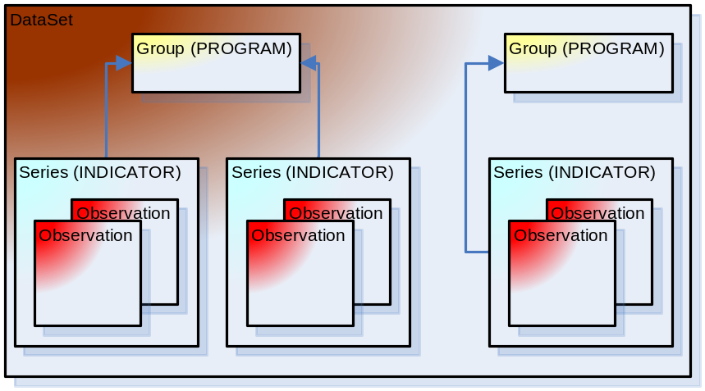

Concepts for Metadata Structure Definition (MSD)

The concepts included in the Metadata Structure Definition are:
- All metadata that does not relate to the time series;

Let’s first list the metadata elements related to the indicator definition, thus all are attached at the code-list level for the CL_INDICATOR code-list.

Concept name | Identifier | Metadata attached to |  | Common / Custom |  | Code-list / type
Administrative Source | ASOURCE | CL_INDICATOR |  | Custom |  | CL_ ASOURCE
Calculation Syntax | CSYNTAX | CL_INDICATOR |  |  | common | string
Calculation Syntax Type | CSTYPE | CL_INDICATOR |  | common |  | CL_CSTYPE
Data Type | DTYPE |  | CL_INDICATOR |  | common | CL_DTYPE
Disaggregation | DISAGG |  | CL_INDICATOR |  | common | CL_DISAGG
Documentation | DOC |  | CL_INDICATOR |  | common | string
Domain Expert | EXPERT |  | CL_INDICATOR |  | common | string
Expected frequency of data collection | FREQUENCY |  | CL_INDICATOR |  | common | CL_PERIODICITY
Expected frequency of data dissemination | FREQ_DISS |  | CL_INDICATOR |  | common | CL_PERIODICITY
Follow Up Period | FPERIOD |  | CL_INDICATOR |  | common | CL_FPERIOD
Guidelines | GUIDE |  | CL_INDICATOR |  | common | string
Health Indicators Framework Level 1 | HIF1 |  | CL_INDICATOR |  | common | CL_HIF1
Health Indicators Framework Level 2 | HIF2 |  | CL_INDICATOR |  | common | CL_HIF2
Indicator Comment | COMMENT_IND |  | CL_INDICATOR | common |  | string
Indicator Definition Date | DDATE |  | CL_INDICATOR |  | common | date
Indicator ICD | INDICATOR_ICD |  | CL_INDICATOR |  | common | String
Indicator OID | INDICATOR_OID |  | CL_INDICATOR |  | common | String
Indicator Set | SET |  | CL_INDICATOR |  | custom | CL_ISET
Indicator Status | STATUS |  | CL_INDICATOR |  | common | CL_STATUS
Keywords | KWORDS |  | CL_INDICATOR |  | custom | CL_KWORDS
M&E Type | METYPE |  | CL_INDICATOR |  | common | CL_METYPE
Maintaining Organization | ORG_MAINT |  | CL_INDICATOR |  | Custom | CL_ORGANIZATION
Methodology | METHOD |  | CL_INDICATOR |  | common | string
Organization Compiling | ORG_COMP |  | CL_ INDICATOR |  | Custom | CL_ORGANIZATION
Organization Responsible | ORG_RESP |  | CL_ INDICATOR |  | Custom | CL_ORGANIZATION
Other Sources | OSOURCE |  | CL_INDICATOR |  | Custom | CL_DSOURCE
Preferred | PREFERED |  | CL_ INDICATOR |  | common | CL_LOGICAL
Preferred Sources | PSOURCE |  | CL_INDICATOR |  | Custom | CL_DSOURCE
Rationale or Purpose | RATIONALE |  | CL_INDICATOR |  | common | string
Short Name | SHORT_NAME |  | CL_INDICATOR |  | common | string
Strengths and limitations | LIMIT |  | CL_INDICATOR |  | common | string

The table below lists metadata elements that can be attached to any code-lists (including CL_INDICATOR) and are useful for computer system processing the data, e.g. to implement incremental updates or data merge algorithms. The concepts names are prefixed by “_” to clearly indicate their generic nature.

Concept name | Identifier | Metadata attached to | Common / Custom | Code-list / type
Code | _CODE | Any | common | String
Created On UTC Date | _CREATED_ON | Any | common | Date time
Description | _DESCRIPTION | Any | common | String
Is Archived | _IS_ARCHIVED | Any | Common | Boolean
Is Read Only | _IS_READONLY | Any | Common | Boolean
Order By | _ORDER_BY | Any | Common | Integer
Unique Identifier | _UID | Any | Common | String
Updated On UTC Date | _UPDATED_ON | Any | common | Date time
User who created the information | _CREATED_BY | Any | common | String
User who last updated the information | _UPDATED_BY | Any | common | String
Version | _VERSION | Any | Common | String
Version Status | _VSTATUS | Any | Common | CL_VSTATUS

Metadata elements may be attached to other code-lists (e.g. CODE, or ISO 11179 REPEAT and MANDATORY), but these are omitted for the sake of brevity.

Here is a list of other usual metadata elements that are attached to code-lists other than CL_INDICATOR. This list is not exhaustive but should be used as guidance.

Concept name | Identifier | Type @ Attachment level | Common / Custom | Code-list / type
Currency | CURRENCY | CL_PROGRAM | common | CL_CURRENCY
Disease Status | DISSTAT | CL_DISEASE | common | CL_DISSTAT
Organization Type | OTYPE | CL_ORGANIZATION | Custom | CL_OTYPE
Program Status | PSTATUS | CL_PROGRAM | common | CL_PSTATUS
Program Type | PTYPE | CL_PROGRAM | custom | CL_PTYPE

The following list of concepts all relate to the CL_GEOGRAPHIC_PLACE_NAME code-list. Their usage will depend on the particular standard used to code geographical places. SDMX-HD recommends using the ISO/3166-2 list of sub-national level 1 codes as reference (see http://www.commondatahub.com/live/geography/state_province_region/iso_3166_2_state_codes ). For sub-national data linked to sub-national level 2 and beyond, SDMX-HD does not recommend any standard coding.

Concept name | Identifier | Type @ Attachment level | Common / Custom | Code-list / type
Country Code | GCODE_COUNTRY | CL_GEOGRAPHIC_PLACE_NAME | Common | CL_GCODE_COUNTRY
Geographic Boundary Type | GBOUNDARY_TYPE | CL_GEOGRAPHIC_PLACE_NAME | common | CL_GBOUNDARY_TYPE
Geographic Latitude | GLATITUDE | CL_GEOGRAPHIC_PLACE_NAME | common | CL_GLATITUDE
Geographic Level | GLEVEL | CL_GEOGRAPHIC_PLACE_NAME | common | CL_GLEVEL
Geographic Longitude | GLONGITUDE | CL_GEOGRAPHIC_PLACE_NAME | common | CL_GLONGITUDE

SDMX-HD

The SDMX-HD standard is based on SDMX-ML data exchange format, the XML version of SDMX. The SDMX-EDI standard is not described here. The following file formats are used:
- The Data Structure Definition (DSD): holds the indicator definition, how indicators are related to each other (hierarchy of numerator, denominator operands), possible dimensions of disaggregation and metadata attributes at various levels;
- The Metadata Structure Definition (MSD): holds metadata related to the various structures of the DSD: indicator definitions, geographical dimension, etc.

Whilst the DSD and MSD files hold structural information and referential metadata, the indicator and the metadata pertaining to them can have actual values. These actual data values are retained in two additional files: a dataset file and a metadata set file.

- The Compact Data Set (CDS) file holds observed values structured according to the DSD;
- The Generic Metadata Set (GMS) file holds the metadata values related to the MSD.

Several output formats exists in SDMX for these dataset and metadata set files. The SDMX-HD standard only supports one for data, the compact format which reduces the amount of data being exchanged between systems.

File organization
Because of the evolving nature of indicator definitions in the health domain, the DSD is rather dynamic. As a result, a single DSD cannot be provided as part of the SDMX-HD standard. Instead, this standard provides the following building blocks, from which a DSD can be constructed:
- DSDTemplate.xml: provides the skeleton of a typical SDMX-HD Data Structure Definition file (DSD):
  - It references the externally-defined common SDMX-HD concepts defined in COMMON/v1.0/conceptschemes/COMMON+SDMX-HD+1.0.xml
  - It must be completed with agency-specific concepts, code-list and hierarchies to form a correct DSD.
  - And last but not least, the essential key families are provided with their typical code-list mappings, but they should also be customized to fit a particular data exchange need.
- MSDTemplate.xml: provides the skeleton of a typical SDMX-HD Metadata Structure Definition file (MSD):
  - It references the externally-defined common SDMX-HD metadata concepts defined in COMMON/v1.0/conceptschemes/ COMMON_MSD+SDMX-HD+1.0.xml and in COMMON_MSD_GEN+SDMX-HD+1.0.xml. The latter file contains system-related metadata (e.g. last update data, isreadonly, etc..)
  - It must be completed with agency-specific metadata concepts and code-list to form a correct MSD.
- Subfolder COMMON\SDMX-HD\v1.0\code-lists\... contains the common SDMX-HD code-lists. These should be considered final for the current version of the standard;
- Subfolder CUSTOM\... contains agency-specific code-lists and concepts that are provided as supplemental information for guidance and should not be considered a core part of SDMX-HD. These concepts and code-lists are maintained by each agency.
Important note: As a result, SDMX-HD requires the DSD file to be provided in all cases: a CDS cannot be transmitted on its own.
The recommended way to package an SDMX-HD message is as follows:
- Package all relevant XML files into a current *.zip archive;
- Always provide the DSD.xml, MSD.xml and GMS.xml files in the root of the archive;
- Always include all *.xsd files (including the standard SDMX ones) to ensure your XML can be fully validated upon import;
- SDMX-HD zip packages must be self-contained: all concepts, code-lists and hierarchies that your data or metadata reference must be included in the zip file, either as inline information within the DSD.xml or MSD.xml files themselves, or as external references pointing to another file contained in the zip package. E.g. if you use a standard SDMX-HD code list:
  - <structure:CodeList id="CL_GENDER" isExternalReference="true" uri="./COMMON/SDMX-HD/v1.0/codelists/CL_GENDER+SDMX-HD+1.0.xml"/>
- this requires the CL_GENDER+SDMX-HD+1.0.xml file to be included in the zip package, under the appropriate directory structure, i.e. in the COMMON/SDMX-HD/v1.0/codelists subfolder;
- Include the CDS.xml in the root of the archive if data is transmitted. When the CDS.xml is included, you must also include the specific CDS.xsd file for validation (see below);

XSD schema validation
The SDMX standard already provides a set of XML schemas (XSD) to validate the correctness of several file types used in SDMX-HD:
- The Data Structure Definition file (DSD.xml) must validate against SDMXMessage.xsd, SDMXStructure.xsd and SDMXCommon.xsd;
- The Metadata Structure Definition file (MSD.xml) must validate against SDMXMessage.xsd, SDMXStructure.xsd and SDMXCommon.xsd;
- The Compact Data Set file (CDS.xml) cannot be validated by any standard XSD as the XSD itself depends on the structure of the DSD.xml file. See below on how to generate the CDS.xsd that corresponds to your specific Data Structure Definition;
- The Generic Metadata Set file (GMS.xml) must validate against SDMXGenericMetadata.xsd.

It is the responsibility of both the sender and the receiver of SDMX-HD files to properly validate XML files against all XSD schemas as part of the system’s import / export routines.
To help with validation and transformation of various SDMX XML file formats, it is recommended to rely on available tools, e.g. those from http://www.metadatatechnology.com
- SDMX Offline Tools Package, Version 1.1, May 2008 release or better;
- SDMX Metadata Editor, Version 1.0, June 2008 release or better.

STEPS to create a compact dataset XSD validation file
- Open your DSD.xml file in the SDMX Offline Tool
- Validate the document is well formed: click
- Validate the document is valid based on standard SDMX schemas: click
- Generate a "COMPACT" XSD schema based on your DSD:
  - Click get this popup window:

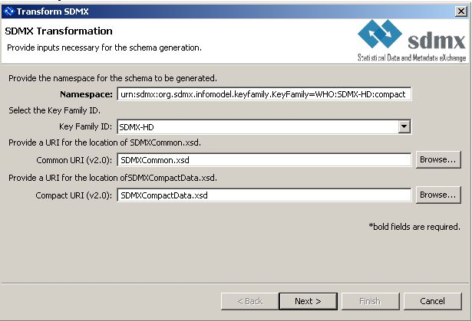

  - Complete the details as shown above and click NEXT
  - Export to CDS.xsd file

- Open your Compact Data Set file (CDS.xml) and add this line to it:
urn:sdmx:org.sdmx.infomodel.keyfamily.KeyFamily=WHO:SDMX-HD:compact CDS.xsd
This leads to the following namespaces for the CDS.xml file:
<?xml version="1.0" encoding="UTF-8"?>
<CompactData
xmlns="http://www.SDMX.org/resources/SDMXML/schemas/v2_0/message"
xmlns:ns="urn:sdmx:org.sdmx.infomodel.keyfamily.KeyFamily=WHO:SDMX-HD:compact"
xmlns:compact="http://www.SDMX.org/resources/SDMXML/schemas/v2_0/compact"
xmlns:xsi="http://www.w3.org/2001/XMLSchema-instance"
xsi:schemaLocation="http://www.SDMX.org/resources/SDMXML/schemas/v2_0/message
SDMXMessage.xsd
urn:sdmx:org.sdmx.infomodel.keyfamily.KeyFamily=WHO:SDMX-HD:compact
CDS.xsd
http://www.SDMX.org/resources/SDMXML/schemas/v2_0/compact
SDMXCompactData.xsd" >

- Now when you validate your CDS.xml file, it will be validated using the CDS.xsd file generated based on the DSD.xml structure.

Data and metadata structure overview
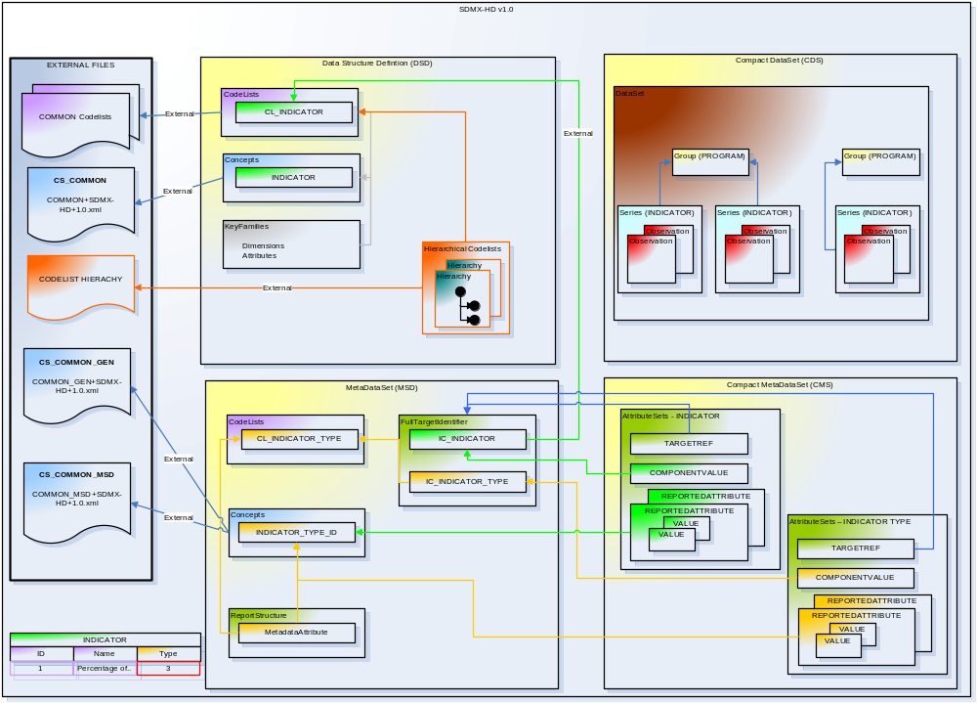
As can be seen from the figure above the structural information (code-lists, hierarchies, concepts) are all part of the Data Structure Definition (DSD) and Metadata Structure Definition (MSD), yet the actual observed data and metadata associated with that observation is stored in the Compact Data Set (CDS) and Generic Metadata Sets (GMS).

Each dimension references the concept and code-list (if needed) used. These dimensions use the core representation code-list or your own custom code-list if the default core representation code-list if not the one you need. By default, the format of the dimensions (using the TextFormat tag) has been left as a string to remain as flexible as possible concerning the data being exchanged.

Likewise, each attribute is given a concept reference and/or code-list reference and is specified as conditional or mandatory. For attributes listed with a code-list reference, the value of that attribute in the XML file corresponds to the code-list code value attribute value. Attributes that have no code-list specified and no core representation specified in the concept hold the actual value.

We will now start to look in more detail at the structure of the XML that is created within the DSD, MSD, CDS and GMS to conform to the SDMX-HD standard. Each section below will contain a set of standardization rules which apply to that section. However, there are some generalized rules which apply throughout which are detailed here:

General Standardization Rules:

- All IDs are in upper case with underscores “_” instead of spaces to separate words e.g. ID=”MY_ITEMS_NAME” and not ID=”MyItemsName”
- When a date and time is created in the XML file it should be created as UTC.
- SDMX-HD files should be “self-contained incremental files”, meaning that only the reference metadata about the transmitted data should be contained in the files. I.e. if your data only references one code from a code-list, then the corresponding code-list should only contain that single code and not all the codes. This is also true for all other elements in SDMX-HD: only include in the DSD and MSD the concepts, code-lists and hierarchical code-lists referenced by your data or metadata. This will help reduce the SDMX-HD file footprint and ensure smooth processing upon import.

Versioning
Each code-list in the SDMX-HD standard has two attributes that are used to manage the version:
- version – This attribute has the version number starting at 1.0
- isFinal – This attribute has two values:
  - true – means that changes to this versioned item (e.g. a code-list) must automatically increase the version attribute value by 0.1 .e.g. 1.0 becomes 1.1
  - false – means that changes to the versioned item (e.g. a code-list) do not impact the overall version i.e. the item is volatile.
Additionally there is also a code-list called CL_VSTATUS that contains the current versions state (Preliminary, Initial, Revised, Final) that can be used if required to give more precision.
In some cases you may wish to retrieve the date in which a code-list code was last updated. In SDMX-HD there is a metadata generic concept called “_UPDATED_ON” (detailed later) which is used to achieve this task. In the case of Hierarchical code-lists where you need to know the last updated date of a CodeRef i.e. when the relationship between two code-list codes changes you need to create a new code-list that map this relationship and use again the “_UPDATEDON”. For example, I have the PROGRAM_INDICATOR_HIERARCHY Hierarchical code-lists and I want to know when the program1 => indicator1 relationship changed. By creating a new code-list called “CL_PROGRAM_INDICATOR”, I can map any metadata to this code-list which in this case is the _UPDATEDON.

Note

- Code-list created to map metadata to hierarchical code-list should only be used for this purpose and not to impose the actual structural relationship. That is what the hierarchical code-lists are for.

Data Structure Definitions (DSD)

This is a top level container that holds all the structural and definition information needed to describe the data structure being created. It does not contain actual data, but is used to create the compact format CDS message containing the data.
The overall structure of a DSD is as follows:

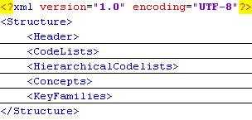

Headers
Each SDMX-HD file has a header which identifies what the data is and who the data was sent from. Below is an XML example of the header in a DSD file:
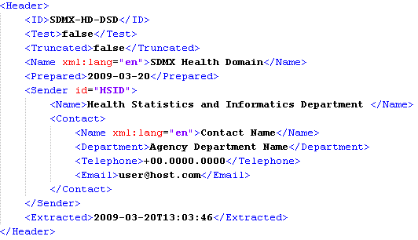
Here are the details concerning the XML header above:

Element Order | Element | Details
1 | ID | This is the ID of the standard being adhered to for this file. To help identify the file as a DSD or CDS, each file should create the ID with the last letters as DSD,CDS,MSD,GMS e.g. The DSD file would have : SDMX-HD-DSD
2 | Test | Set to false (See SDMX standard for more details on the function of this element)
3 | Truncated | Set to false (See SDMX standard for more details on the function of this element)
4 | Name | This is the full name of the system sending the data
5 | Prepared | This is UTC date when the data was prepared.
6 | Sender | This is name of the system that sent the data. In order to help importing system identify different types of data from the same systems, the sending system ID can be post fixed to help identify the data being sent e.g. IMR-UNGASSDATA. This post fixed value should then correspond to the DatasetId value in the compact data set file.
6.1 | Sender Name | A more detailed description of the Sender ID
6.2 | Sender Contact
6.2.1 | Contact Name | The person responsible for the data being sent
6.2.2 | Contact Department | The department responsible for the data being sent
6.2.3 | Contact Telephone | The contact telephone number of the person or department responsible for the data being sent
6.2.4 | Contact Email | The contact email of the person or department responsible for the data being sent
7 | Extracted | The UTC date the data was extracted from a system

Body

Code-lists

A code-list is a predefined list of values used as reference or lookup list that defines the representation of dimensions, attributes, and other structural parts of SDMX defined in the key families. It can be supplemented by metadata which indicates how codes are organized into hierarchies.

Here is an example of the xml representation of a code-list using disease:

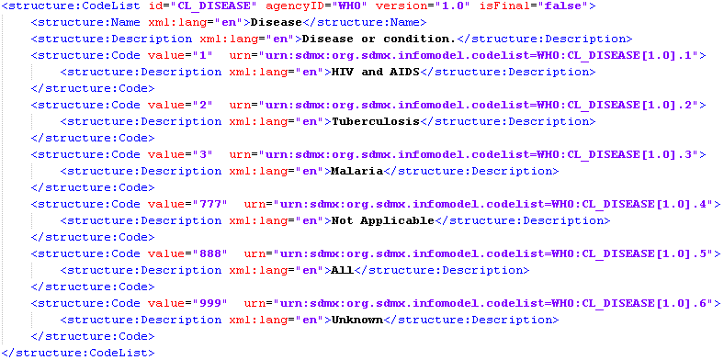

The SDMX-HD “common” code-lists are stored in an external file using the isExternalReference and uri attributes so they are actually represented in the DSD like this:

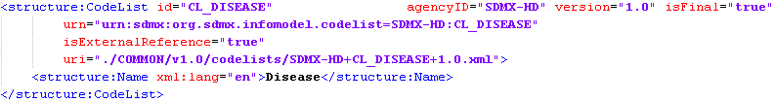

Standardization Rules:

- All code-list IDs are prefixed with CL_
- All code-list Code elements have URN attribute that globally uniquely identifies the code.
- Code-list URN attributes are formatted as:
  - “urn:sdmx:org.sdmx.infomodel.code-list.=<AGENCY>:<CODE_LIST_ID>”
- Code URN attributes are formatted as:
  - “urn:sdmx:org.sdmx.infomodel.code-list.Code=<AGENCY>:<CODE_LIST_ID>[Version].<Value>”
- Parent Code’s are not supported as any Hierarchical code-list can be represented in a Hierarchical code-list defined later in this document.
- The recommended way to code the code-lists values is by using sequential integers starting at 1. These are only used as references from CDS or GMS files to the DSD or MSD code-lists respectively. If a code is internationally agreed upon, e.g. ISO3166-1 alpha 2 country codes (see CL_GCODE_COUNTRY), it can be used instead of the sequential integer numbering.
- Most code-lists use three standard additional items whose value is prefixed with “_” to clearly indicate these elements are standard code for all SDMX-HD code-lists:
  - _NA: Not Applicable
  - _UNK: Unknown
  - _ALL: All
- For code-lists values coded with sequential integers, additional codes may be provided as metadata in the MSD file by using the _CODE metadata concept.

Special Code-lists
Some code-lists are special in the sense that their usage has specific meaning in SDMX-HD. The section below describes these code-lists, as well as insight into their use.

Placeholder code-lists
To ensure a standard naming convention, the following “volatile” codelists have been created empty:
- CL_GEOGRAPHIC_PLACE_NAME
- CL_INDICATOR
- CL_ISET
- CL_ORGANIZATION
- CL_PROGRAM
- CL_TIME_PERIOD
As the name implies the content of these code-list changes often, so the isFinal attribute is set to false. These codelists need to be completed by the system implementing a specific SDMX-HD message. These code-lists will thus often contain codes in addition to SDMX-HD standard codes, so the special “additional” folder has been created for them.

Logical code-list
A special code list to manage logical states has been created. In most cases a simple Boolean value is enough. However, using the logical codelist allows you to manage special cases such as Unknown or Not Applicable.
Operand code-list
The operand codelist indicates the element type of an operation. For example
3 + 4 = 7
The 3 and 4 are elements of an operation and their type is: 'Number'
The current operand code-list only contains 'Numerator' and 'Denominator' as 'Number' as implicit to most operations. Here are examples of Numerator and Denominator usage:
3 / 4 = 0.75 displayed as 75% for percentage indicators
3 / 4 = 0.75 displayed as 3:4 for ratio indicators

Special Value code-list
There is often a need to specify a reason why a value was not entered as opposed to simply being ignored or forgotten. An example of this is when you want to say “I do not have the data” i.e. it is “missing”. To indicate a value as “missing” the SPECIAL_VALUE attribute contains a CL_SPECIAL_VALUE codelist value. When the SPECIAL_VALUE attribute is present, the OBS_VALUE should be ignored if a value is found.
The same principal applies to the LOGICAL_VALUE attribute which is used to answer a Yes/No question. As the OBS_VALUE data type is decimal the values should be ignored and LOGICAL_VALUE value (which references the CL_LOGICAL codelist) should be used.

Hierarchical Code-lists

This is a nested structure that is used to manage the structural relationships between code-lists. Below is an example of the XML representation of a Hierarchical code-list:

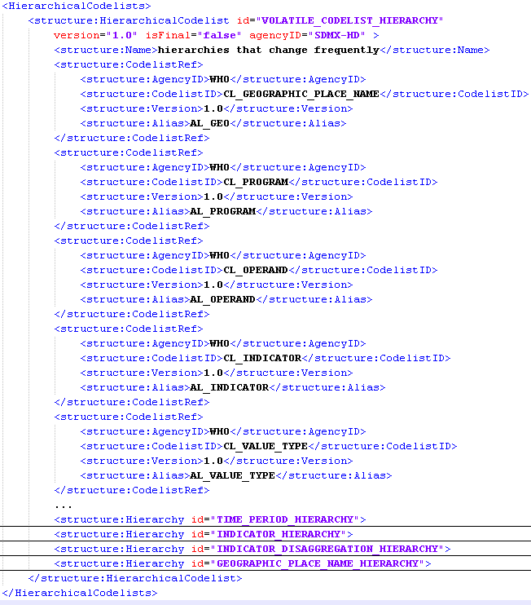

The initial part of the Hierarchical code-list creates an Alias which references the Agency, Version and code-list to use in the hierarchy (these are called code-list references). Each hierarchy then references the appropriate Code-list References via its alias. In the example above we have three hierarchies defined:

- TIME_PERIOD_HIERARCHY
  - This hierarchy gives structure to Yearly, Quarterly and Monthly time periods. It is particularly useful for fiscal years for example:
    - 2008-Q1
      - 10-2007
      - 11-2007
      - 12-2007
    - 2008-Q2
      - 01-2008
      - 02-2008
      - 03-2008
- INDICATOR_HIERARCHY
  - This hierarchy gives structure to composite indicators that relate to other indicators via an operand.
- INDICATOR_DISAGGREGATION_HIERARCHY
  - This hierarchy gives structure to indicators and the disaggregations they use.

Other examples of hierarchy that should be created if required are:

- GEOGRAPHIC_PLACE_NAME_HIERARCHY
  - This hierarchy gives structure to international, national and sub-national geographical places
- PROGRAM_HIERARCHY
  - This hierarchy gives structure to programmatic items and the sub-programs used.

Expanding the TIME_PERIOD_HIERARCHY element we see a series of nested CodeRef elements used to impose a parent child relationship:

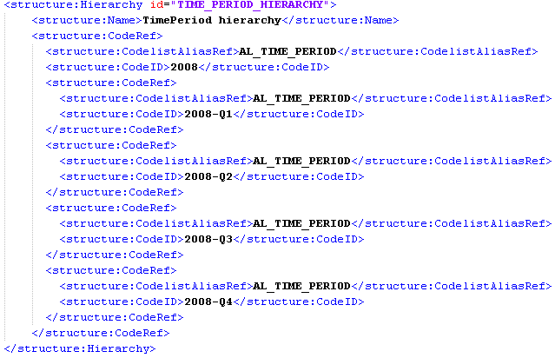

Each CodelistAliasRef references the Alias defined in the first part of the HierarchicalCodelist and the CodeID references the Alias’s Code-list Code to use.
Here are the details concerning the XML above:

Element Order | Element | Details
1 | Name | The name for this Hierarchy
2 | CodeRef | A reference node in the Hierarchy that is a recursive structure as a CodeRef element can contain a child CodeRef element and so on and so on.
2.2 | CodelistAliasRef | An alias reference to the CodelistReference element in the HierarchicalCodelist
2.3 | CodeId | The code-list ID (Value attribute) for this item

Standardization Rules:

- A hierarchical code-list should be used instead of a Code-list with Parent Codes.
- A hierarchy that has no child relationships should not be created.

Concept Schemes
Concept Schemes represent a collection of concepts which are used to describe a meaningful set of distinct concepts, to be used in the reporting of data or metadata. Here are an example of two concepts scheme with the actual list of concepts referenced in an external file:

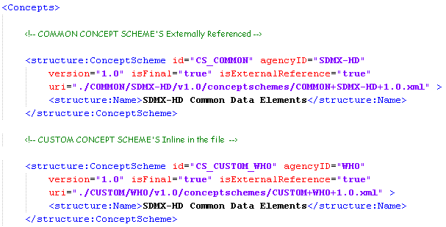

Concepts
This is an entity in which you wish to hold data. Here is an example of the XML representation of a CS_COMMON concept list:

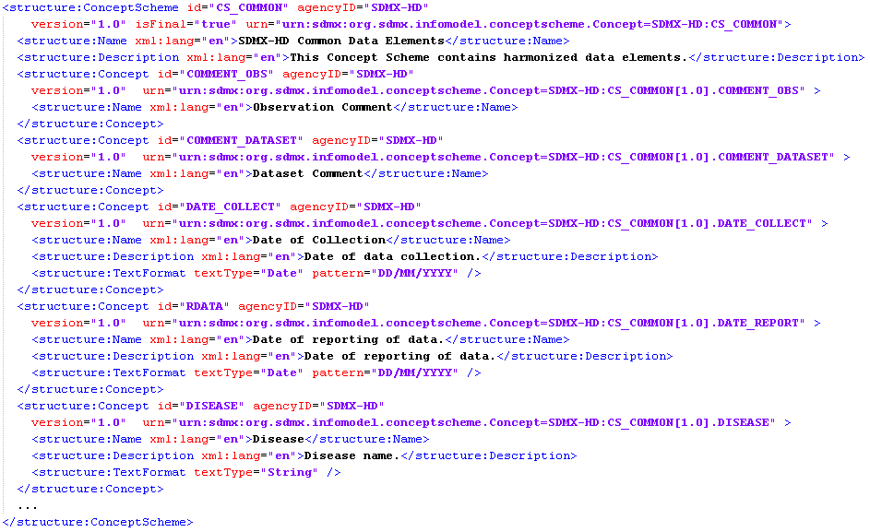

Concepts that are common to all agencies are found in the ConceptScheme with an id=’CS_COMMON’. To provide for agency specific concepts, each agency can have its own concept scheme as well (See CS_CUSTOM_WHO in screen shot above). These agency-specific custom concepts should include a coreRepresentation attribute to indicate which code-lists should be used by default. If no such attribute is included and a code-list is not specified later via a key families dimension, then the value for that dimension is not a code-list value, but a free text value. A user’s comment is a good example of this. Normally, however, as comments for observations are common, a concept for this would exist in the common ConceptScheme.

Standardization Rules:

- All ConceptScheme ID’s are prefixed with CS_
- Common Concepts are listed in the ConceptScheme as id=“CS_COMMON”. These concepts, as the name implies, are common to all agencies.
- coreRepresentation attributes need to added to agency specific custom concepts if they are code-list driven.

Key Families

Key Families hold information about how concepts are associated with the measures, dimensions, and attributes of a data, along with information about the representation of data via a code-list. Essentially, Key Families map concepts to code-lists and specify the manner in which the data is measured.

Here is an example of the XML representation of Key Families:

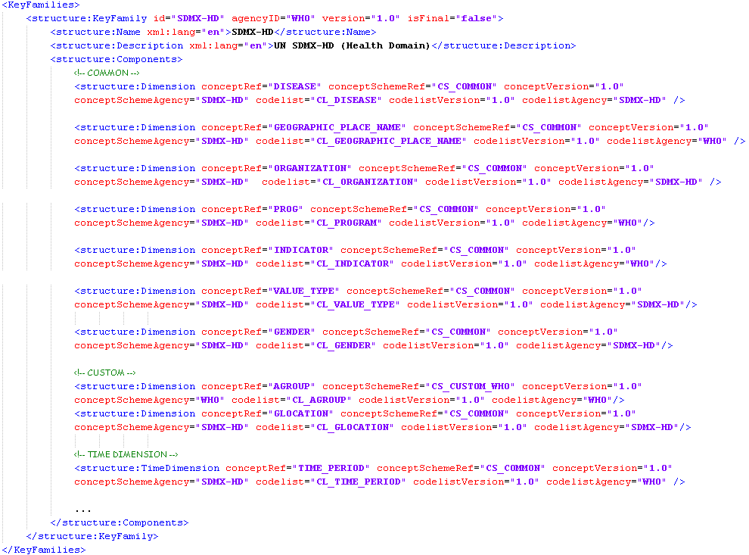

Each concept is given a default core representation code-list. Concepts that require different code-lists (i.e. CUSTOM) will use code-lists specified for the Concept. Whilst the default code-list for a concept is specified at the concept level, the mapping of concepts and code-lists is specified at the Key Family level in the DSD.

This means that concepts that have common code-lists are specified with these code-lists within the Key Families. Concepts that have custom code-lists do NOT have code-lists specified within the Key Families, allowing each agency to add the custom code-list that meet their needs. Should no code-list be specified within the Key Families, then the concepts default core representation should be used. If no default core representation is specified, then the value for this item is not a code-list value but a free text value, e.g. a comment.

Primary Measures
This component identifies the Concept used for the main observation value i.e. an indicator’s value. It is defined as a Double data type to cater for the most common scenario of collecting indicator values as counts, money or percentage values. In some cases, an indicator value has a text value, such as is the case with Indicator of type Logical that have a value of yes or no. In these cases an additional attribute is attached to the observation to reference a code-list. Here is an example of the OBS_VALUE primary measure:

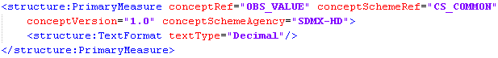

Dimension
This component identifies the concept and code-list used for the dimensional values associated to the Primary Measure. When you specify the concepts to use for a Dimension you can either use common concepts (CS_COMMON) and their corresponding code-lists or you can override a common concept’s code-list and use your own agency specific code-list. Looking at the Gender dimension in the screen shot above you can see that whilst the ConceptSchemeRef attribute references CS_COMMON the Code-listAgency attribute indicates that the code-list used (CL_GENDER) is a custom code-list specified by UNAIDS.

Groups
Groups are a way to group series of data. One can imagine each series of data as an indicator which has observed values for a Key Family grouped together, for example, into a group that represents the observations for specific programs. In the example below, we have specified one new group called “PROGRAMS” that has two mandatory attributes: PROG and DISEASE (these are references to Dimensions). These two mandatory attributes link the group to each series in the compact dataset XML file with the same attribute values. Here is an example of a Group called PROGRAMS:
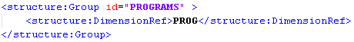

Standardization Rules:

- Dimensions that use Concepts that are NOT common, do not have by default the code-list associated to the Dimension (See GENDER in XML above). This is because GENDER does not have a common code-list and so the actual code-list selected is left open to each specific implementation of this standard.

TimePeriod
The time dimension in SDMX-HD is represented by the TimePeriod concept (CL_TIME_PERIOD code-list), which defines the time period of a series of observations. The following code lists have been created for reference purpose only to use in constructing your CL_TIME_PERIOD code-list:
- CL_YEAR
- CL_QUARTER
- CL_MONTH
- CL_WEEK
- CL_DAY
The creation of codes in CL_TIME_PERIOD follows naming conventions in order to avoid custom parsing of date formats representing different time periods.
To populate the CL_TIME_PERIOD with a code representing the first quarter of 2008, using the code values specified in the reference code lists above, you use value=”2008-Q1” where 2008 is the code value for the year in the CL_YEAR reference codelist and Q1 is the code value for Quarter1 in the CL_QUARTER reference codelist. When creating your CL_TIME_PERIOD codelist made up of a combination of the reference code lists, the code value attribute should be formatted by joining the values by ”-“ and in the follows order:
Year-Quarter-Month-Week-Day
e.g.
- 2008-Q1 - 1st Quarter of 2008
- 2008-10 - October 2008
- 2008-W50 - 50th Week of 2008
- 2008-D300 - 300th day of 2008
- 2008-01-W03 - Week 3 in January 2008

Below is a summary SDMX-HD concepts related to “Time” information to help you understand related items:
- TIME_PERIOD – is the period of an observation (indicator value) is valid for
  - e.g. 2008-Q1
- DATE_COLLECT – is the actual date a user entered the observation (indicator value)
  - e.g. 2009-04-04T09:40:00 , or a survey date, e.g. 2005
- FREQUENCY - is recommended frequency of data collection.
  - e.g. Quarterly
- PERIODICITY - is actual frequency of compilation of data.
  - e.g. Yearly.
- FPERIOD - is follow-up period.
  - e.g. 6, 12, 18 months.
- RPERIOD - is the reporting period
  - e.g. 2008 UNGASS
- RDATA – is the date of reporting of the data
  - e.g. November 2007 (for UNGASS 2008)
- FDATA - is the year of first available data
  - e.g. 2005 (for UNGASS 2008 dataset containing data collected over 2005-2007)
- LDATA - is the year of latest available data
  - e.g. 2007 (for UNGASS 2008 dataset containing data collected over 2005-2007)

Attributes
This component identifies any metadata you wish to associate with the Primary Measure. Attributes can be attached to any of the following levels:
- Datasets, Groups, Series and Observations
As well a being given an Assignment Status of:
- Mandatory or Conditional
Here is an example of the mandatory and condition attributes:
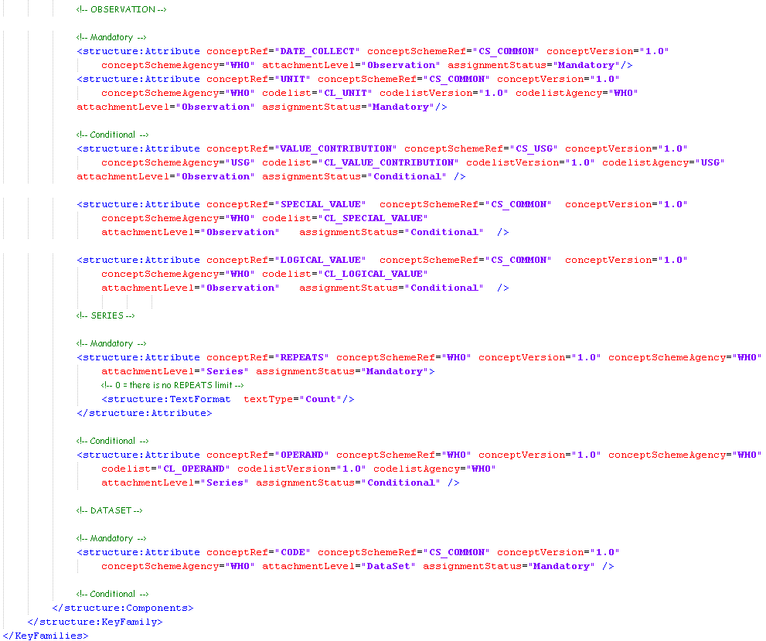

As you can see in the example above attributes are either Mandatory or Conditional and assigned to Observations, Series or Groups. If an attribute is related specifically to the primary measure and adds context to the observed value, it can be added as a DSD attribute. However, if the attribute is reference metadata, it should be added to the metadata MSD and GMS files detailed later.

In the example above, we can see four “special” attributes detailed below:

Assignment Status | Attribute Name | Attribute Definition
Mandatory | REPEATS | Added to support ISO 11179, this attributes indicates the max occurrence of an Indicator value for a series of data.
Conditional | LOGICAL_VALUE | When an indicator is of type Logical this attribute is used instead of the OBS_VALUE to indicate the code-list value to use for the value.
Conditional | SPECIAL_VALUE | In many cases “special” values are need so the user can indicate the data was missing, not applicable or not available. This attribute is used instead of the OBS_VALUE to indicate which code-list “special” values the use selected.
Conditional | VALUE_CONTRIBUTION | Here we have an example of an agency specific attribute that has been added specifically for a USG implementation of the SDMX-HD standard

Note

- The Primary Measure does not have a code-list reference as values are entered and therefore can’t be limited by a code-list.
- The TimeDimension is a special dimension that must be included in any Data Structure Definition which will be used for time-series data such as the Compact Data Set format used by SDMX-HD

Standardization Rules:

- Attributes attached to an Observation should be generated in Compact Dataset XML file.

Data
The actual data (i.e. not the structure) is written to a generated XML file. Several formats are available through SDMX. However, only the compact dataset (CDS) format is supported as part of this SDMX-HD standard.
Note that indicator definitions can entirely be coded by using the Data Structure Definition (DSD), Metadata Structure Definition (MSD) and Generic Metadata (GMS) files: the CDS file is only required when indicator values are transmitted.

Headers
The Header section of this XML file is exactly the same structure as the Header section of the DSD.

Body
The Body section of this XML file is exactly the same structure as the Body section of the DSD.

Dataset
The dataset element is the containing element used to hold the data being reported. In a case where the data sent from a system varies, that data should be identified using the dataset code attribute.

Groups & Series
Groups are used to logically group a series of observations. Each grouping of data is specified using the element name as the name of the group. For example if one wants to create groups of data for a conference and a workshop, then groups in the DSD, and the CDS are defined with the mandatory attribute values populated to identify the group.

Series are used to further sub-divide the groups. As a reminder, the SDMX-HD data structure follows these principles for organization of observations into series, groups and datasets:

- The SDMX primary measure (OBS_VALUE) records indicator values;
- They are grouped into SDMX series by indicator (INDICATOR);
- One or more indicators are associated with one or more programmes (PROG) via SDMX groups;
- The SDMX DataSet can contain indicator values linked to one or more programs (read contain one or more SDMX groups);

Here is an example of two groups called “PROGRAM” and two series created in the Compact Dataset XML file representing the an Indicator of type count:

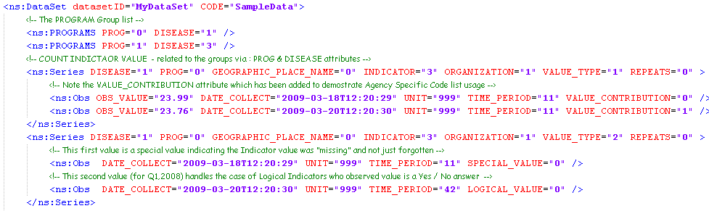

These series are linked to groups via the same matching attributes names and values. In this case we have DISEASE and PROG. Conditional attributes can also be attached to groups via Key Family component attributes.

Observations (Obs)
The observation element (Obs) records the actual indicator value. To add context to the value, each observation has mandatory and conditional attributes.
Here is an example of a percentage indicator with numerator and denominator observations identified via the conditional attribute operand to help readability:

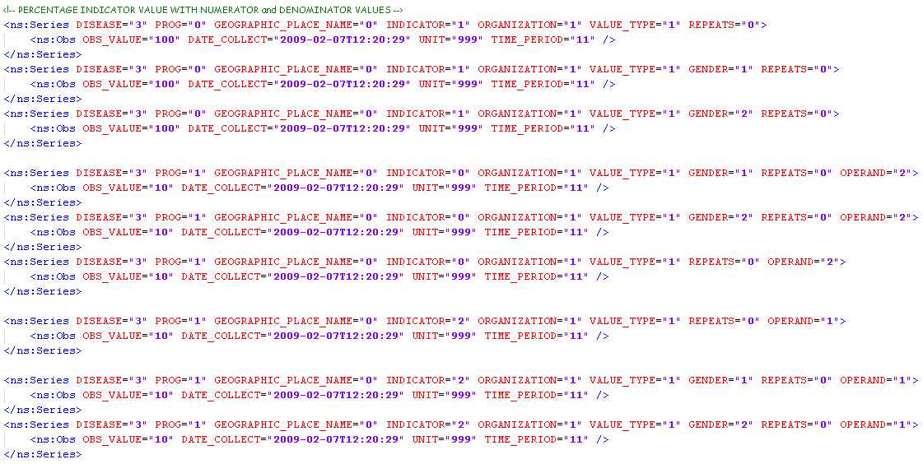
Note

- No relationship between Indicators is present in the CDS. That is done via the hierarchical code-lists defined in the DSD.

Metadata

Compact format is the only currently supported SDMX-HD format. When authoring Compact Dataset XML files, metadata is generated in to two files:
- Metadata Structure Definition
  - This file is the equivalent of the Data Structure Definition file, but for metadata
- Compact Metadata Set
  - This file is the equivalent of the Compact Dataset file, but for metadata

Metadata Definitions

Headers
The Header section of this XML file is exactly the same structure as the Header section of the DSD.

Body
The Body section of this XML file is exactly the same structure as the Body section of the DSD.

Code-lists
Only code-lists that have not already been defined in the DSD should appear in the Metadata Structure Definition. References to code-lists in the DSD are later marked as External in the IdentifierComponent RepresentationScheme section of the XML document.

Concepts

There is one concept per metadata item you wish to author. Each concept also has a TextFormat element which identifies the type of the metadata being sent. As is the case with the DSD concepts, the MSD “common” concepts are also externally referenced. However, the MSD also has a notion of re-usable generic concepts that can be applied across multiple metadata scenarios e.g. Name, Description, OrderBy etc. These generic concepts are prefixed by “_” to help identify them easily as re-usable and also externally referenced.

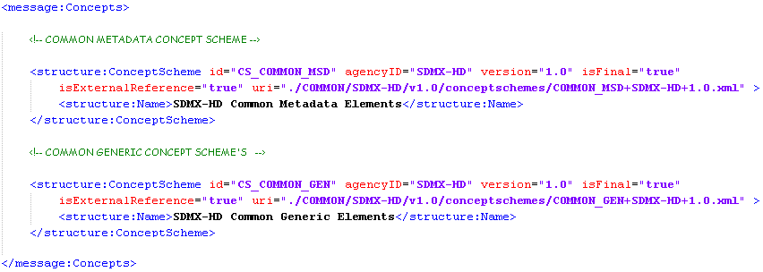

Whilst these two MSD concepts files are externally referenced in a similar way they are conceptually different, since common concepts, as the name implies, are concepts that are common across multiple agencies. However generic MSD concepts are common concepts that apply to multiple metadata attributes across several code-lists.
Below we see the same screenshot as above with examples of non-Generic (specific) concepts used inline in the MSD XML file:

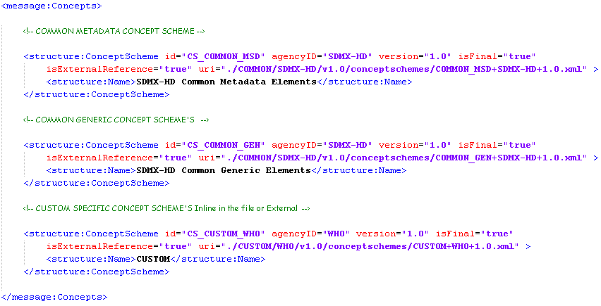

Here is the full list of valid textType that can be used in the SDMX-HD standard:

Data Type | Description
String | A string datatype corresponding to W3C XML Schema's xs:string datatype.
BigInteger | An integer datatype corresponding to W3C XML Schema's xs:integer datatype.
Integer | An integer datatype corresponding to W3C XML Schema's xs:int datatype.
Long | A numeric datatype corresponding to W3C XML Schema's xs:long datatype.
Short | A numeric datatype corresponding to W3C XML Schema's xs:short datatype.
Decimal | A numeric datatype corresponding to W3C XML Schema's xs:decimal datatype.
Float | A numeric datatype corresponding to W3C XML Schema's xs:float datatype.
Double | A numeric datatype corresponding to W3C XML Schema's xs:double datatype.
Boolean | A datatype corresponding to W3C XML Schema's xs:boolean datatype.
DateTime | A time datatype corresponding to W3C XML Schema's xs:dateTime datatype.
Date | A time datatype corresponding to W3C XML Schema's xs:date datatype.
Time | A time datatype corresponding to W3C XML Schema's xs:time datatype.
Year | A time datatype corresponding to W3C XML Schema's xs:gYear datatype.
Month | A time datatype corresponding to W3C XML Schema's xs:gMonth datatype.
Day | A time datatype corresponding to W3C XML Schema's xs:gDay datatype.
MonthDay | A time datatype corresponding to W3C XML Schema's xs:gMonthDay datatype.
YearMonth | A time datatype corresponding to W3C XML Schema's xs:gYearMonth datatype.
Duration | A time datatype corresponding to W3C XML Schema's xs:duration datatype.
URI | A datatype corresponding to W3C XML Schema's xs:anyURI datatype.
Timespan | A complex datatype specifying a start date (xs:dateTime) and a duration (xs:duration). Note that this is not allowed as the text type representing a dimension.
Count | A simple incrementing Integer type. The isSequence facet must be set to true, and the interval facet must be set to "1".
InclusiveValueRange | This value indicates that the startValue and endValue attributes provide an inclusive numeric range of type xs:double.
ExclusiveValueRange | This value indicates that the startValue and endValue attributes provide an exclusive numeric range, of type xs:double.
Incremental | This value indicates that the value increments according to the value provided in the interval facet, and has a true value for the isSequence facet.
ObservationalTimePeriod | This is a time datatype, and is the conventional representation of time in SDMX formats. It is a union of W3C XML Schema time datatypes and a set of codes for indicating quarterly, tri-annual, bi-annual, and weekly time periods. See common:TimePeriodType for specifics.

There are also additional attributes that can be added to the TextFormat to better validate the data. Here is a list of those attribute along with a description of their purpose:
- decimals - Integer (# of digits to right of decimal point)
- startValue - Value (of specified type)
- endValue - Value (of specified type)
- interval - Double
- isSequence - true | false (indicates a sequentially increasing value)
- minLength - Integer (# of digits)
- maxLength - Integer (# of digits)
- pattern - (a regular expression, as per W3C XML Schema)
- timeInterval – Duration

Standardization Rules:

- Concept URN attributes are formatted as:
  - “urn:sdmx:org.sdmx.infomodel.conceptscheme.Concept=<AGENCY>:<ELEMENT_ID>[Version]”

Metadata Structure Definition
A MetadataStructureDefinition element performs several functions: it groups sets of objects into "targets" against which reference metadata may be reported. Targets define the structure of the reference metadata "keys" which identify specific types of reported metadata, and describe the valid values for populating the keys. Also, Metadata Structure Definitions provide a presentational organization of concepts for reporting purposes. The MetadataStructureDefinition contains two sub elements: TargetIdentifiers and ReportStructure. Target Identifiers define a list of Full Target Identifiers to be used by the ReportStructure. In SDMX-HD there is only 1 FullTargetIdentifiers element defined. Here is an example of the MetadataStructureDefinition XML:

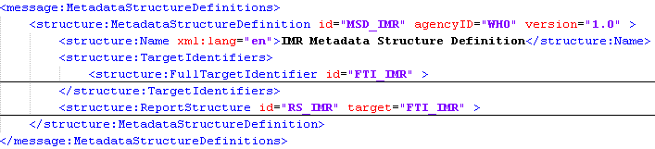

Standardization Rules:

- MetadataStructureDefinition URN attributes are formatted as:
  - “urn:sdmx:org.sdmx.infomodel.metadatastructure.MetadataStructureDefinition=<AGENCY>:<ELEMENT_ID>[Version]”

IdentifierComponent

To reference concepts defined in DSD file you need to create an IdentifierComponent element that references the concept (via the TargetObjectClass child element) and the Code-list (via the RepresentationScheme child element).
Here is an example of an IdentifierComponent referencing the CL_INDICATOR code-list:
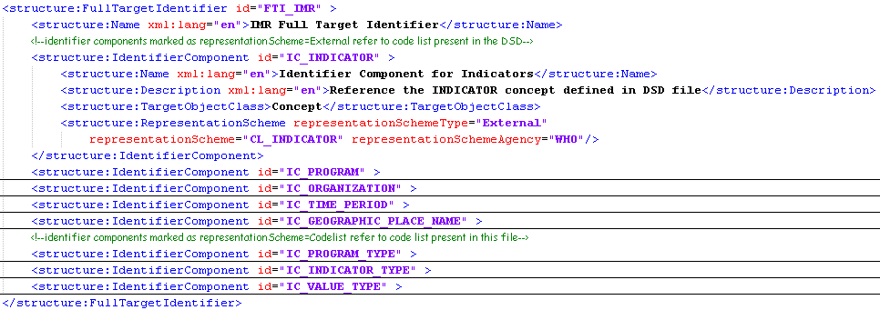
Note that the RepresentationScheme type is set to External which means that code-list is located in the DSD, otherwise you set the type to “Codelist” to identify a code-list used in the MSD file.

Standardization Rules:

- IdentifierComponent URN attributes are formatted as:
  - urn="urn:sdmx:org.sdmx.infomodel.metadatastructure.IdentifierComponent=<AGENCY>:< MetadataStructureDefinitionID>[Version].<FullTargetIdentifierID>.<IdentifierComponentID>"

ReportStructure

This element reference will be used with FullTargetIdentifier to define the metadata fields to work with. Specifically, the ReportStructure element contains the full list of metadataAttribute elements needed to complement the CDS data being generated. Below is an example of a ReportStructure with some metadataAttributes:

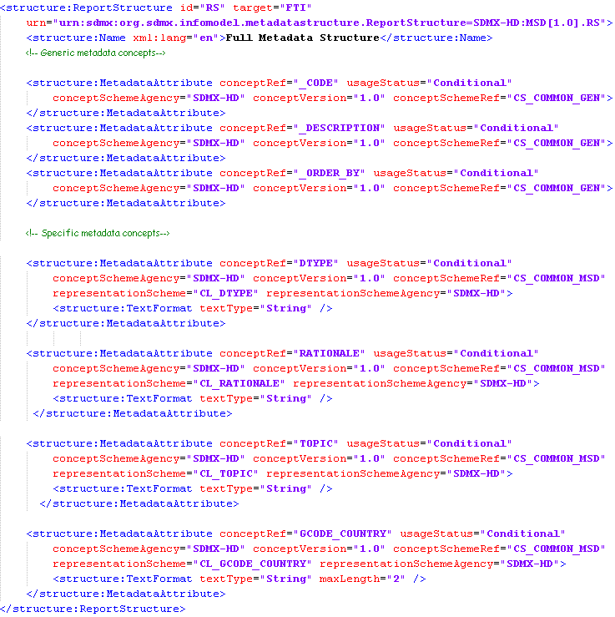

Metadata Attribute

There are two types of metadata attribute used in this standard:
- GENERIC
These are concepts that can be re-used more that once. That is, if you have common metadata attributes that occurs frequently and have the same data type e.g. name, description, orderby etc these items can be declared once and re-used as needed. Each one of these generic metadata concepts are prefixed by “_” to ease the readability of the XML generated as well as allowing importing systems to identify these special case generic concepts.
- SPECIFIC
These are concepts that are used only once.
For both generic and specific metadata attributes, the XML structure does not differ. Generic metadata attributes do reduce the XML footprint as it does not need redefining for each usage.

When a metadata attribute is defined, you can either reference a generic or a specific concept. In both cases, one can either specify a code-list or not to represent this metadata attribute. Here is an example with two metadata attributes: one with and one without a code-list.
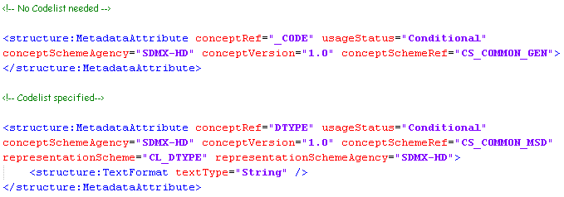
Standardization Rules:

- The MetadataStructureDefinition ID will be prefixed by MSD_
- The FullTargetIdentifier ID will be prefixed by FTI_
- The IdentifierComponent ID will be prefixed by IC_
- Generic MetadataAttribute concepts are prefixed by _
- Specific MetadataAttribute concepts are NOT prefixed by _

Metadata Set data

Headers

The header section of this XML file is exactly the same structure as the header section of the DSD.

Body

Metadata Set
This element references the MetadataStructureDefinition file associated with the metadata contained in this file. The following example show the child elements of the MetadataSet which reference elements within the Metadata Structure Definition XML file:
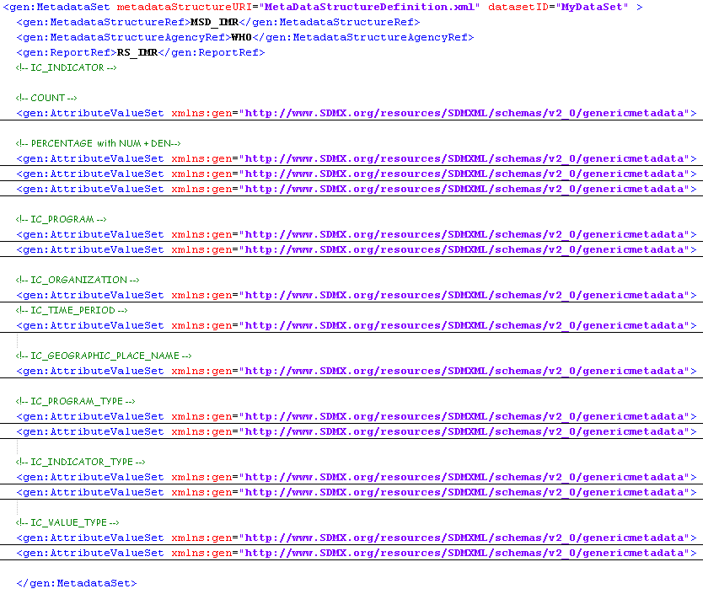

Attribute Value Set

Each metadata set has a list of AttributeValueSet element. These elements contain all the metadata to complement the observation made in the CDS. When we expand the AttributeValueSet element in the example above for the count Indicator we see the following:

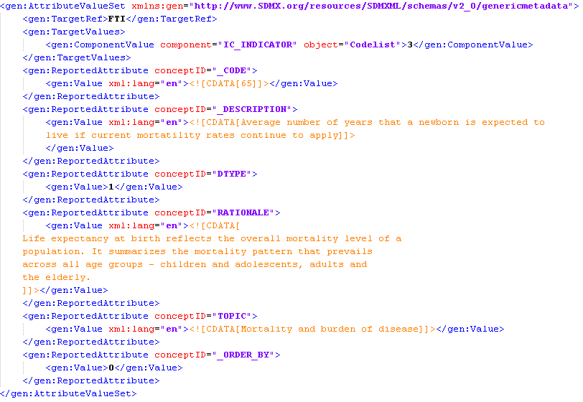

TargetRef

This element is used to reference the Full Target Identifier in the MSD that contains the IdentifierComponent we wish to work with.

TargetValues

This element contains the list of ComponentValue elements each of which references an IdentifierComponent in the Full Target Identifier.

ComponentValue
This element references which MetadataStructureDefinition IdentifierComponent to use. Two attributes are used by this element to define this mapping:
- component="IC_ORGANIZATION"
  - The reference to the IdentifierComponent to use
- object="Code-list”
  - Confirmation of the type object to use

The actual value of the ComponentValue element corresponds to the Code-list Code value the reported attribute metadata is associated with. For example if we have:

This means the data in the ReportedAttribute elements is related to the Indicator with a Code Value of 3 in the CL_INDICATOR_LIST.

ReportedAttribute

This element contains the list of actual metadata values. A conceptID attribute references the concept in the MSD to which this data applies. Here is an example of ReportedAttributes:
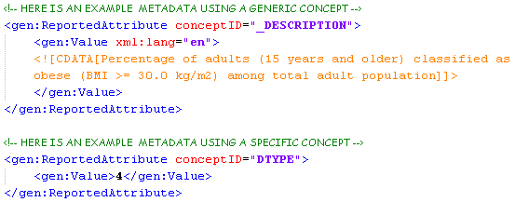
Note

- As the conceptID in the ReportedAttribute references the same concepts as the MSD MetadataAttribute these items are therefore linked in this way.

Standardization Rules:
- The value specified in the Value element of a ReportedAttribute must correspond to the Text type specified in the Metadata Structure Definition Concept

